LAB 3.3
Task 1: AI-Generated Logic for Reading Consumer Details
Scenario: An electricity billing system must collect accurate consumer data.
Prompt used: # Generate a simple Python program that reads previous units, current units, and customer type for an electricity billing system, calculates the units consumed give code in python

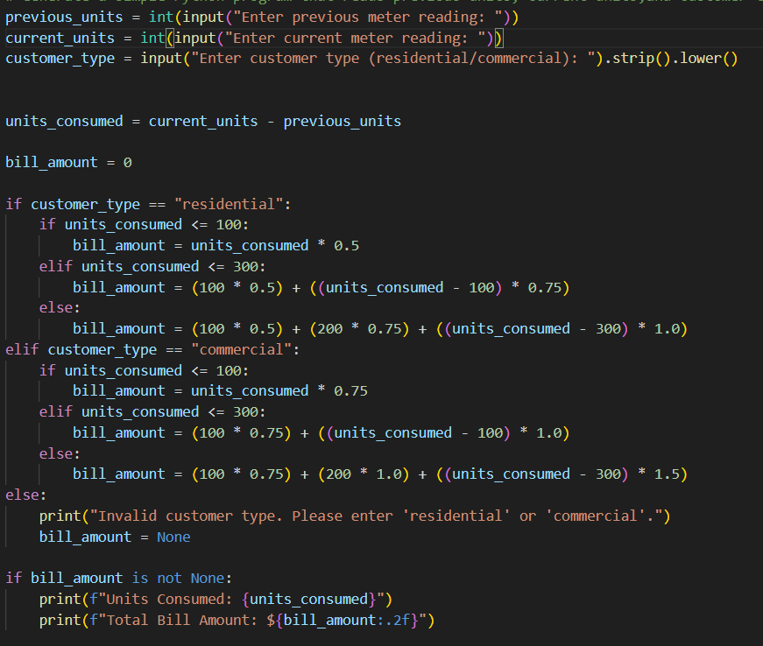

Sample output:
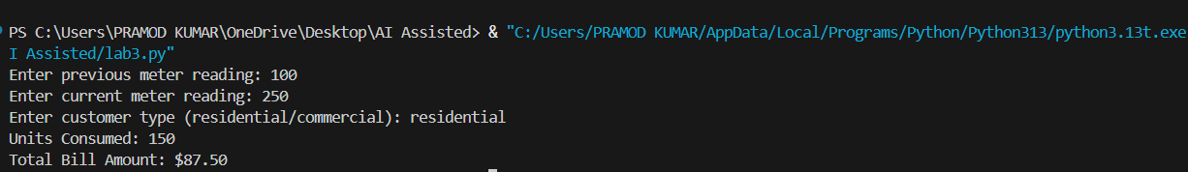
Task 2: Energy Charges Calculation Based on Units Consumed
Scenario: Energy charges depend on the number of units consumed and customer type.
Prompt used: # using existing python electricity billing program calculate energy charges using conditional logic for Domestic, Commercial, and Industrial consumers based on units consumed

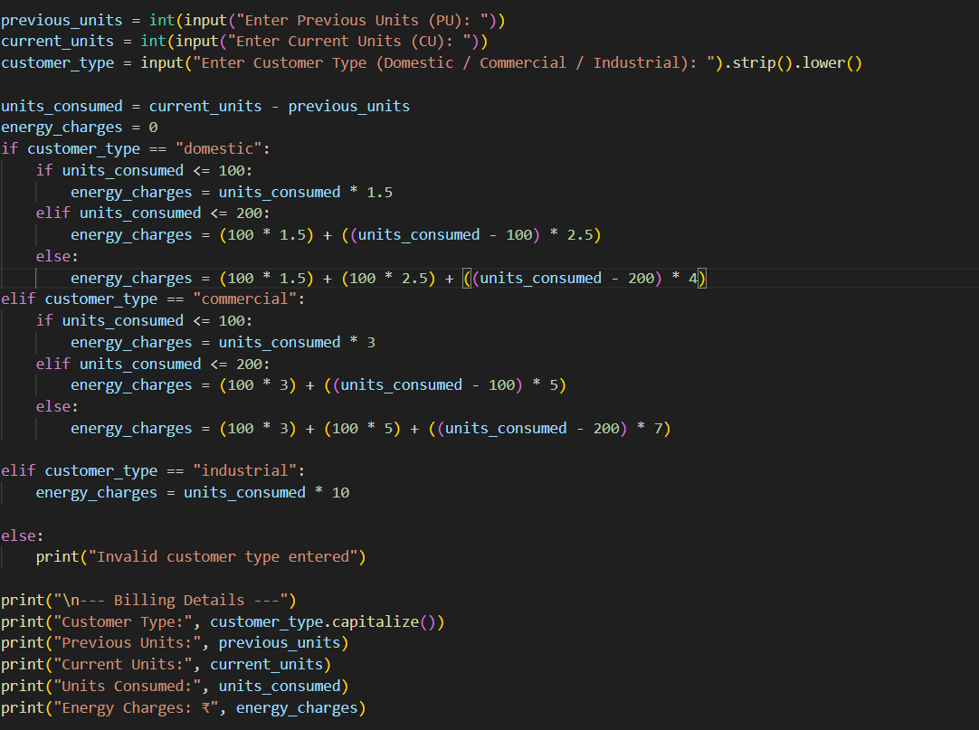
Sample output:
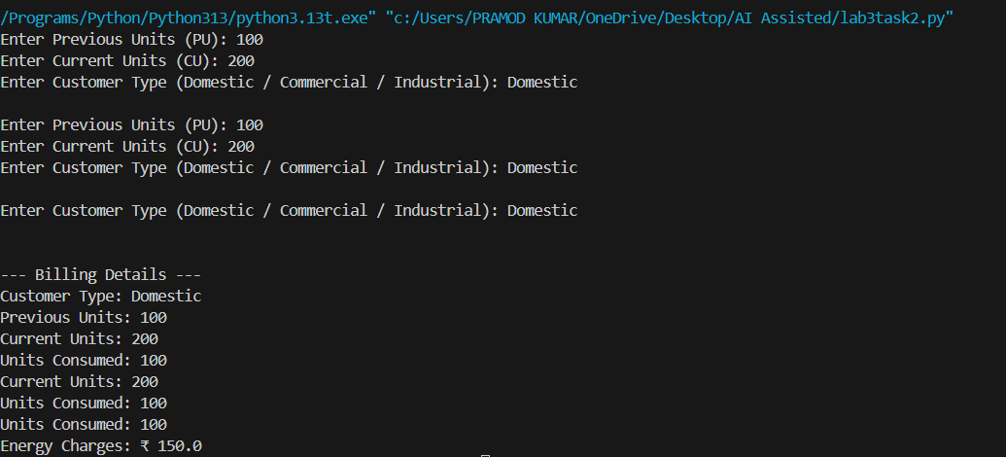

Task 3: Modular Design Using AI Assistance (Using Functions)
Scenario: Billing logic must be reusable for multiple consumers.
Prompt used: # Generate Python electricity billing program using user-defined functions to calculate and return energy charges and fixed charges for different consumer types
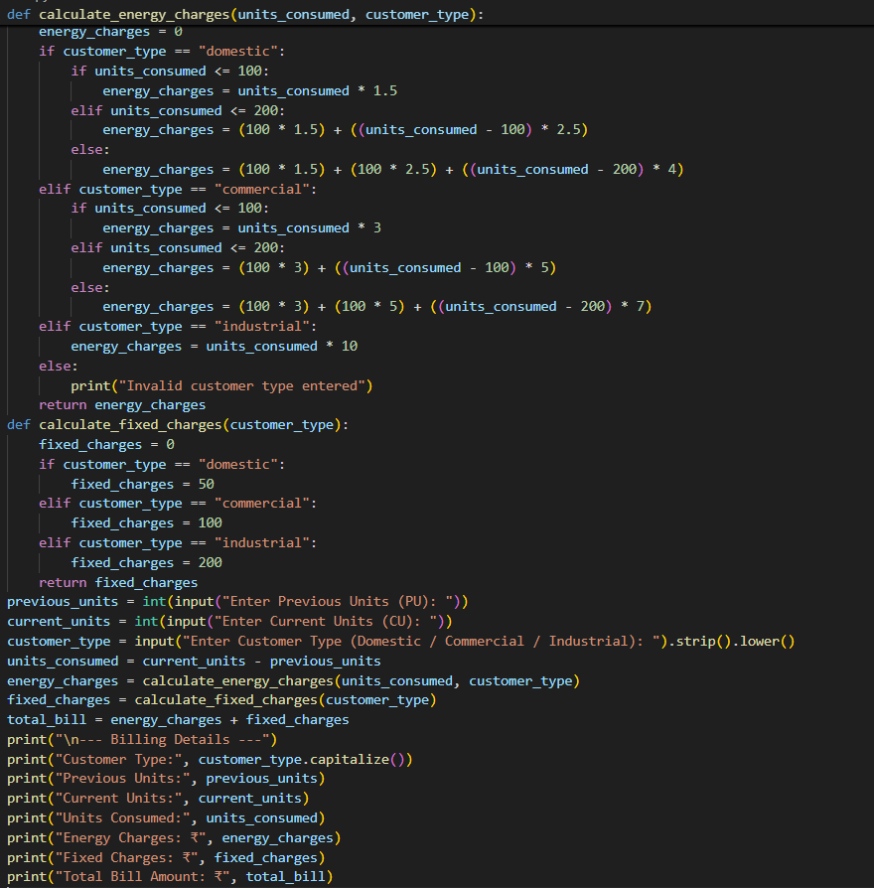

Sample output:
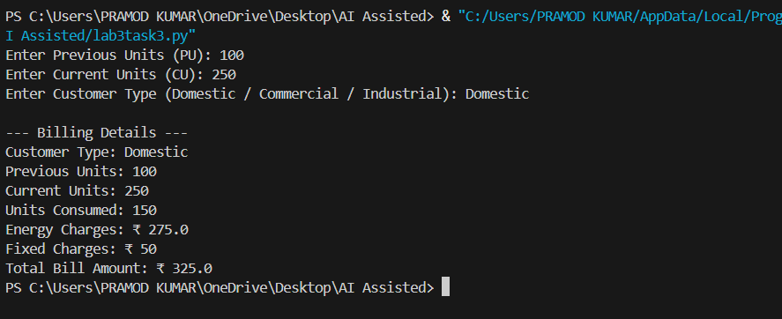
Task 4: Calculation of Additional Charges
Scenario: Electricity bills include multiple additional charges.
Prompt used: # Extend the existing Python electricity billing program to accurately calculate and display Fixed Charges, Customer Charges, and Electricity Duty

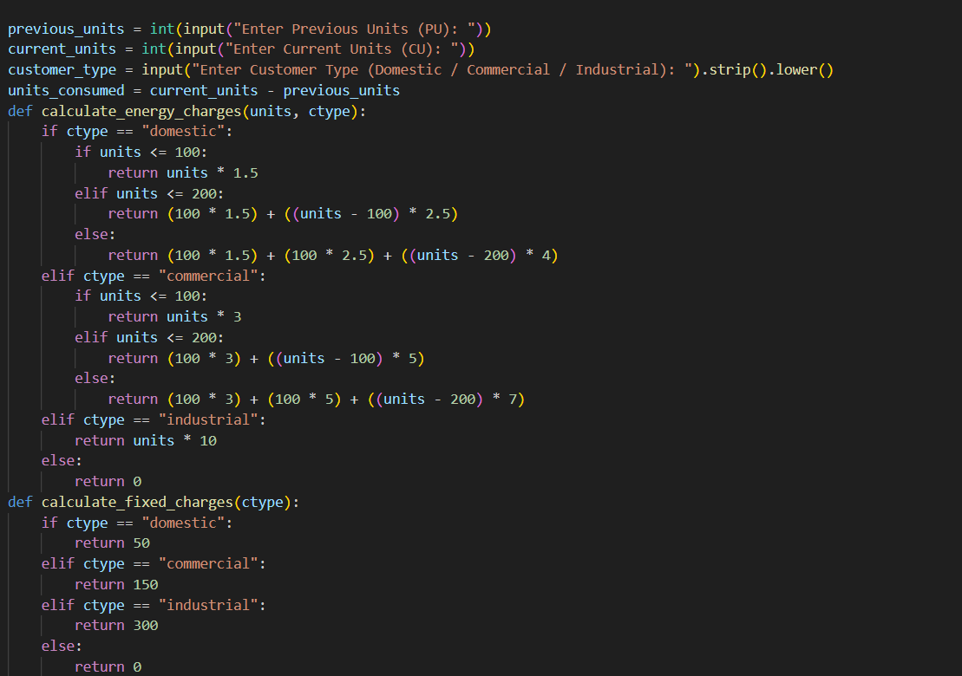
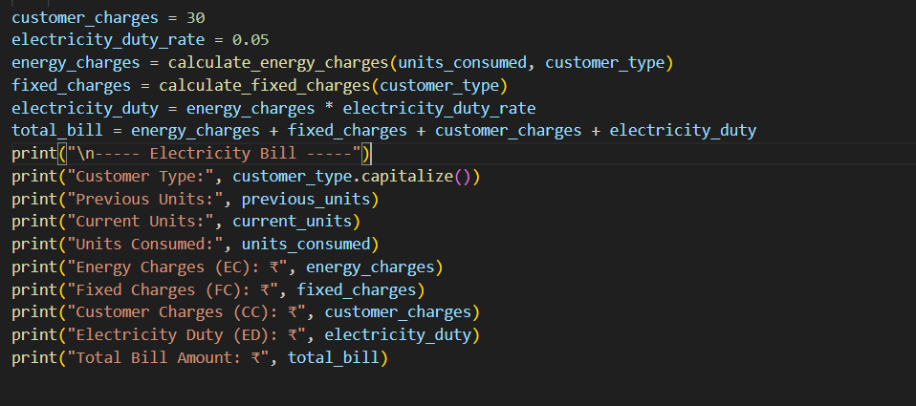

Sample output:
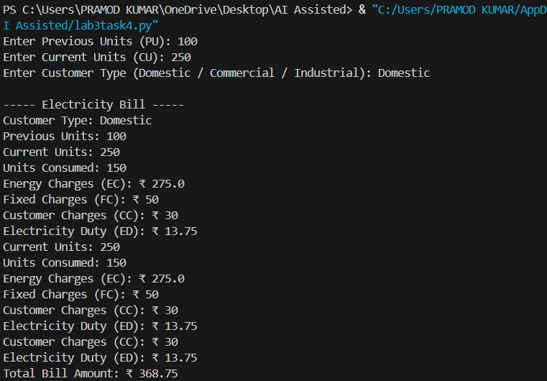

Task 5: Final Bill Generation and Output Analysis
Scenario: The final electricity bill must present all values clearly.
Prompt used: Develop a complete Python electricity billing application that calculates Energy Charges , Fixed Charges , Customer Charges , Electricity Duty, computes the total bill, displays a neatly formatted bill output
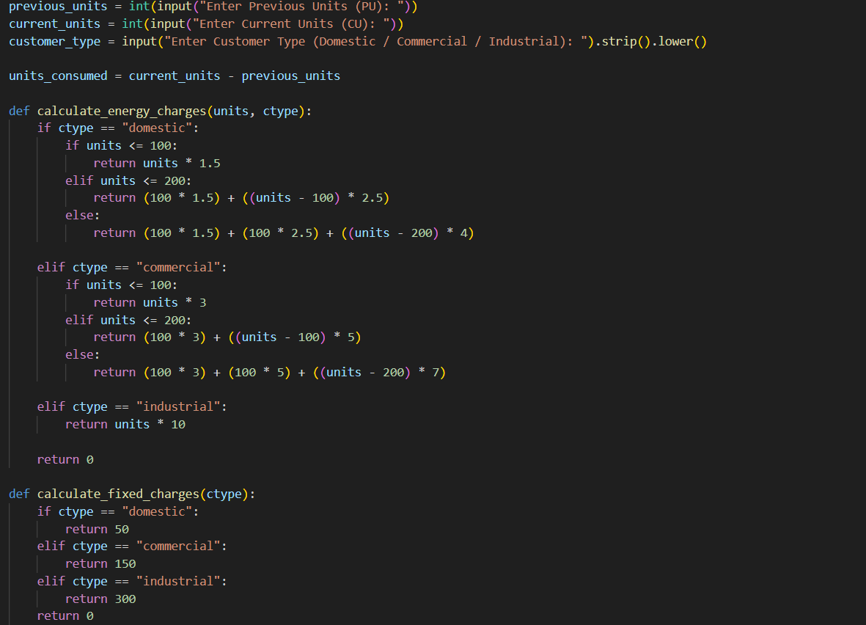
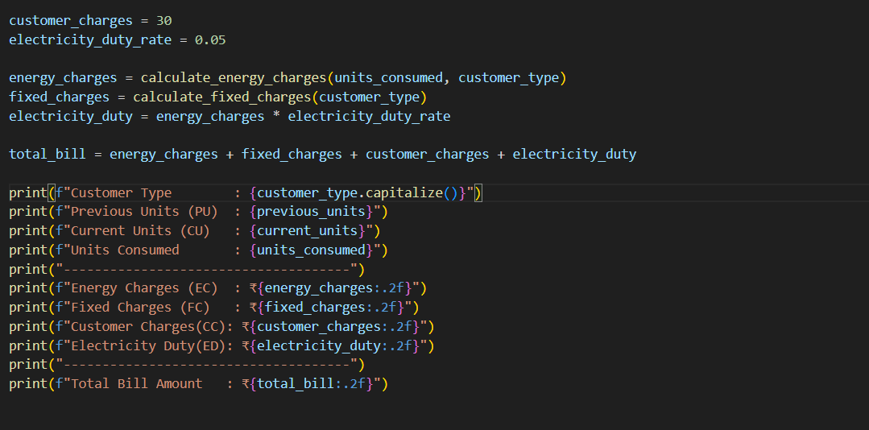
Sample output:
